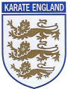
Whitstable and Faversham
Shotokan Karate club

Kion Kata

